DBMS
LAB 8

LAB REPORT

NAME: SACHIN HANSDA
ROLL NO.: 111601019

1. Import database from “largeRelationsInsertFile.sql”

2. Check the status of student table.
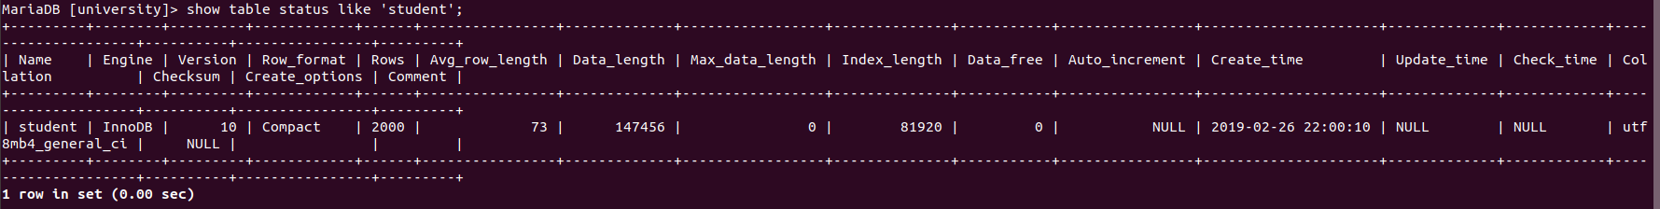

3. Profiler for MariaDB
a. Set ​ profiling ​ option on
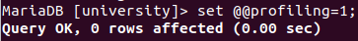

3. b. Show profile after execution of query to fetch details of students from ​ student
table whose name is ‘wood’.
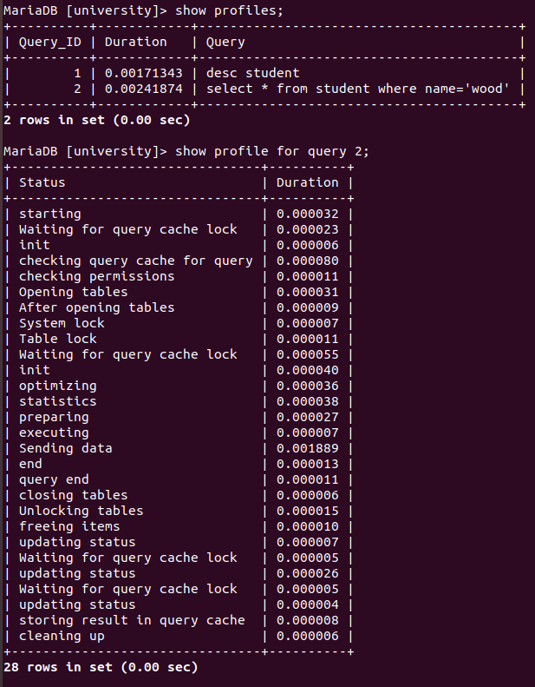

3. c. What is bottleneck for this query ? [Which task required most of the time]
ans: Sending data

3. d. Show list of processes running in your DB
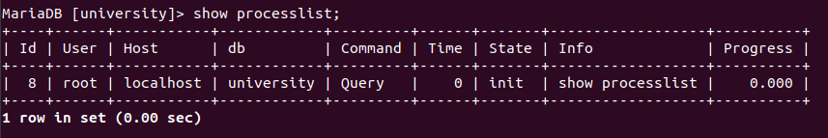
4. Change indexing and check performance
a. List all the ​ storage engines ​ . Which one is default? Find out which storage engine
support hash index.
Ans:
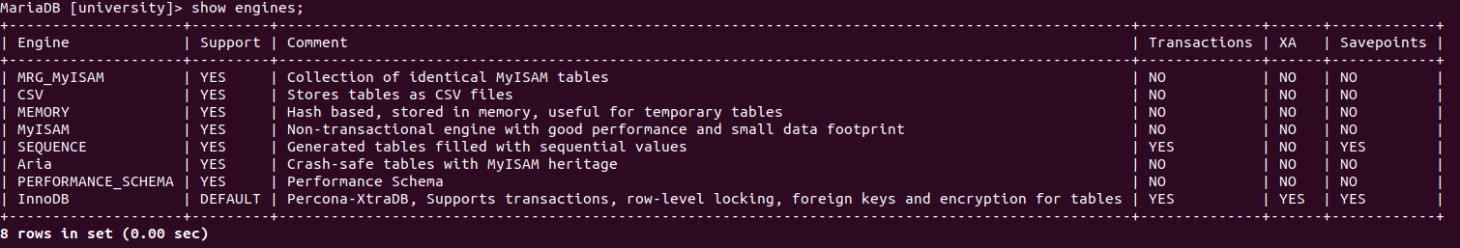

Default engine: InnoDB
MEMORY support hash index

4. b. Create a table ​ takes_hash ​ , cloned from ​ takes ​ table but use <ENGINE> as
storage engine where <ENGINE> support hash index. Create an hash index
‘take_hash_gr’ ​ on ​ grade ​ of table takes_hash
ans:

4. c. Show the current default index present in ​ takes ​ . If you try to create an hash index
‘take_gr’ ​ on ​ grade ​ attribute of t ​ akes . ​ What will happen? [check what kind of
indexes are there in ​ takes ​ table and what is the type of ‘take_gr’]. Report your
observations.
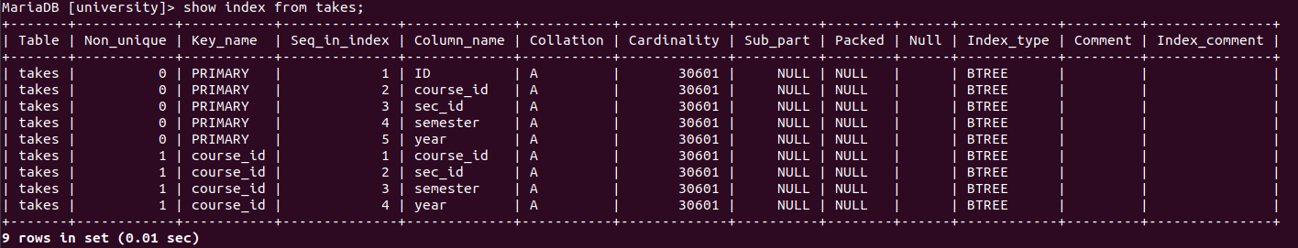

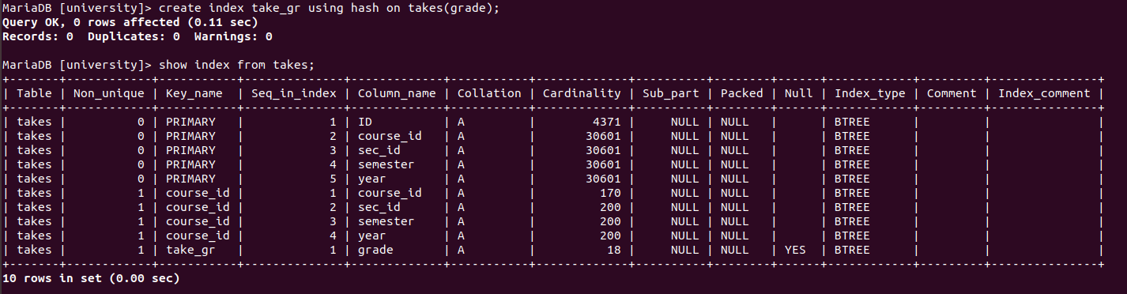
OBSERVATION: ttakes table has btree indexes. take_gr index is not hash index because the current engine of takes table does not hash indexing. take_gr index is btree index.

4. d. Compare the performance of following SQL query in both table ​ takes ​ and
takes_hash ​ “​ select * from <table_name> where grade like
'%C%​ '. Report your observation
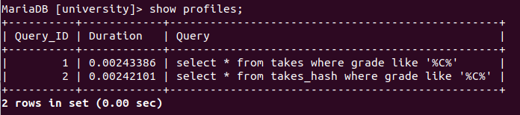

OBSERVATION: table takes_hash takes less time than table takes

4. e. Try to create an unique index on ​ grade ​ of ​ takes. ​ Report your observation
OSERVATION: error occurs because grade ‘B+’ has duplicate entries

4. f. Create an composite index on ​ ID ​ and ​ course_id ​ in ​ takes

4. g. Check the present indexes in ​ takes
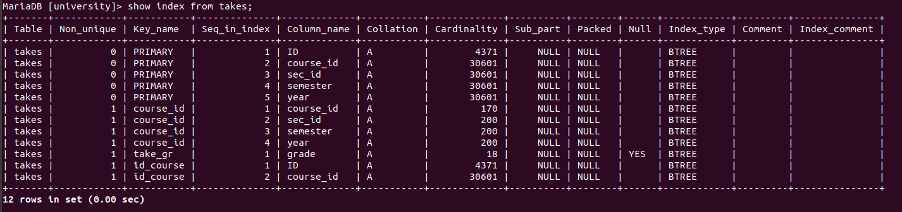

5. Physical level parameter
a. Check the data directory
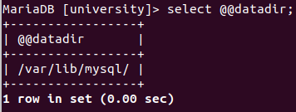

5. b. Create a test database, and a table candidates with columns id and name. Insert
values (1,tom),(2,jerry). Check the files for candidates.

SQL Code:

drop table if exists candidates;

create table candidates(
id varchar(5),
name varchar(10),
primary key(id));

insert into candidates values ('1','tom');
insert into candidates values ('2','jerry');
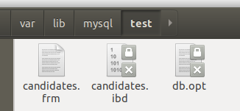

5.c. create table places with columns city and country. Insert two records.
SQL Code:

drop table if exists places;

create table places(
city varchar(20),
country varchar(20),
primary key(city,country));

insert into places values ('Jamshedpur','India');
insert into places values ('Palakkad','India');

5. d. Create a view view_location by merging candidates and places tables side by
side that is four columns and matching the records with the order of input. Check
the location of the view, and how it is stored. Compare the size of files
corresponding to views and tables.

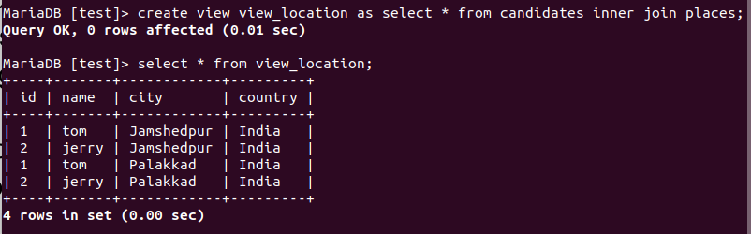
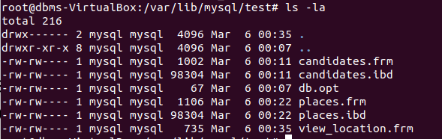
5. e. Create a trigger check_city that will update entries for cities to Proper casing (that
is palakkad -> Palakkad). Check the location where this trigger is created, and
the information is stored about the trigger with the table.

SQL Code:

drop trigger if exists check_city;
delimiter $$
create trigger check_city
before insert on places
for each row
begin
set @atemp = SUBSTRING(new.city,1,1);
set @atemp = UCASE(@temp);
set @btemp = SUBSTRING(new.city,2);
set @ctemp = CONCAT(@temp,@btemp);
set new.city = @ctemp;
end;$$
delimiter ;

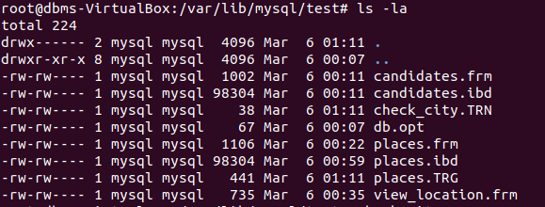
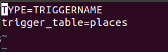

5.f. Check the following system variables
i.Default storage engine
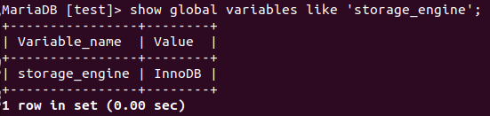

5. f. ii. Buffer size
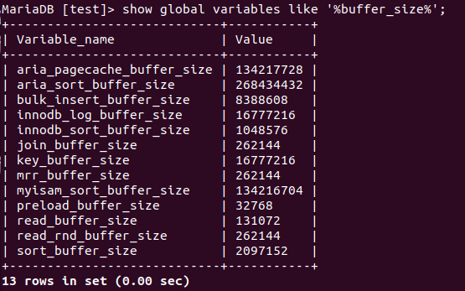
5. f. iii. Change the buffer size half of current buffer size.

